NumPy Creating Arrays

NumPy is used to work with arrays. The array object in NumPy is called ndarray.

We can create a NumPy ndarray object by using the array() function.

### **Example**

import numpy as np  
  
arr = np.array([1, 2, 3, 4, 5])  
  
print(arr)  
  
print(type(arr))

[1 2 3 4 5]

<class 'numpy.ndarray'>

To create an ndarray, we can pass a list, tuple or any array-like object into the array() method, and it will be converted into an ndarray:

### **Example**

Use a tuple to create a NumPy array:

import numpy as np  
  
arr = np.array((1, 2, 3, 4, 5))  
  
print(arr)

[1 2 3 4 5]

## **0-D Arrays**

0-D arrays, or Scalars, are the elements in an array. Each value in an array is a 0-D array.

### **Example**

Create a 0-D array with value 42import numpy as np  
  
arr = np.array(42)  
  
print(arr)

42

## **1-D Arrays**

An array that has 0-D arrays as its elements is called uni-dimensional or 1-D array.

These are the most common and basic arrays.

### **Example**

Create a 1-D array containing the values 1,2,3,4,5:

import numpy as np  
  
arr = np.array([1, 2, 3, 4, 5])  
  
print(arr)

[1 2 3 4 5]

## **2-D Arrays**

An array that has 1-D arrays as its elements is called a 2-D array.

These are often used to represent matrix or 2nd order tensors.

NumPy has a whole sub module dedicated towards matrix operations called numpy.mat

### **Example**

Create a 2-D array containing two arrays with the values 1,2,3 and 4,5,6:

import numpy as np  
  
arr = np.array([[1, 2, 3], [4, 5, 6]])  
  
print(arr)

[[1 2 3]

[4 5 6]]

## **Check Number of Dimensions?**

NumPy Arrays provides the ndim attribute that returns an integer that tells us how many dimensions the array have.

### **Example**

Check how many dimensions the arrays have:

import numpy as np  
  
a = np.array(42)  
b = np.array([1, 2, 3, 4, 5])  
c = np.array([[1, 2, 3], [4, 5, 6]])  
d = np.array([[[1, 2, 3], [4, 5, 6]], [[1, 2, 3], [4, 5, 6]]])  
  
print(a.ndim)  
print(b.ndim)  
print(c.ndim)  
print(d.ndim)

0

1

2

3

# NumPy Array Indexing

## **Access Array Elements**

Array indexing is the same as accessing an array element.

You can access an array element by referring to its index number.

The indexes in NumPy arrays start with 0, meaning that the first element has index 0, and the second has index 1 etc.

### **Example**

Get the first element from the following array:

import numpy as np  
  
arr = np.array([1, 2, 3, 4])  
  
print(arr[0])

1

## **Access 2-D Arrays**

To access elements from 2-D arrays we can use comma separated integers representing the dimension and the index of the element.

Think of 2-D arrays like a table with rows and columns, where the row represents the dimension and the index represents the column.

### **Example**

Access the element on the first row, second column:

import numpy as np  
  
arr = np.array([[1,2,3,4,5], [6,7,8,9,10]])  
  
print('2nd element on 1st row: ', arr[0, 1])

2nd element on 1st dim: 2

## **Slicing arrays**

Slicing in python means taking elements from one given index to another given index.

We pass slice instead of index like this: [start:end].

We can also define the step, like this: [start:end:step].

If we don't pass start its considered 0

If we don't pass end its considered length of array in that dimension

If we don't pass step its considered 1

### **Example**

Slice elements from index 1 to index 5 from the following array:

import numpy as np  
  
arr = np.array([1, 2, 3, 4, 5, 6, 7])  
  
print(arr[1:5])

[2 3 4 5]

### **Example**

Slice elements from index 4 to the end of the array:

import numpy as np  
  
arr = np.array([1, 2, 3, 4, 5, 6, 7])  
  
print(arr[4:])

[5 6 7]

### **Example**

Slice elements from the beginning to index 4 (not included):

import numpy as np  
  
arr = np.array([1, 2, 3, 4, 5, 6, 7])  
  
print(arr[:4])

[1 2 3 4]

## **STEP**

Use the step value to determine the step of the slicing:

### **Example**

Return every other element from index 1 to index 5:

import numpy as np  
  
arr = np.array([1, 2, 3, 4, 5, 6, 7])  
  
print(arr[1:5:2])

[2 4]

# ****Percentiles****

**25th Percentile** - Also known as the first, or lower, quartile. The 25th percentile is the value at which 25% of the answers lie below that value, and 75% of the answers lie above that value.  
  
**50th Percentile** - Also known as the Median. The median cuts the data set in half.  Half of the answers lie below the median and half lie above the median.  
  
**75th Percentile** - Also known as the third, or upper, quartile. The 75th percentile is the value at which 25% of the answers lie above that value and 75% of the answers lie below that value.

# numpy.percentile() in python

**numpy.percentile()**function used to compute the nth percentile of the given data (array elements) along the specified axis. 

***Syntax :****numpy.percentile(arr, n, axis=None, out=None)****Parameters :******arr :****input array.****n :****percentile value.****axis :****axis along which we want to calculate the percentile value. Otherwise, it will consider arr to be flattened(works on all the axis). axis = 0 means along the column and axis = 1 means working along the row.****out :****Different array in which we want to place the result. The array must have same dimensions as expected output.****Return :****nth Percentile of the array (a scalar value if axis is none)or array with percentile values along specified axis.*

# Python Program illustrating

# numpy.percentile() method

import numpy as np

# 1D array

arr = [20, 2, 7, 1, 34]

print("arr : ", arr)

print("50th percentile of arr : ",

       np.percentile(arr, 50))

print("25th percentile of arr : ",

       np.percentile(arr, 25))

print("75th percentile of arr : ",

       np.percentile(arr, 75))

**Output :**

arr : [20, 2, 7, 1, 34]

50th percentile of arr : 7.0

25th percentile of arr : 2.0

75th percentile of arr : 20.0

# numpy.var() in Python

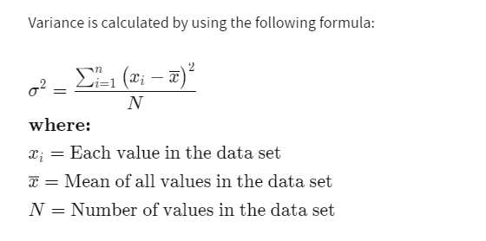

**numpy.var(arr, axis = None) :** Compute the variance of the given data (array elements) along the specified axis(if any).

# Python Program illustrating

# numpy.var() method

import numpy as np

# 1D array

arr = [20, 2, 7, 1, 34]

print("arr : ", arr)

print("var of arr : ", np.var(arr))

**Output :**

arr : [20, 2, 7, 1, 34]

var of arr : 158.16

# Pandas

**Pandas** is an open-source library that is built on top of NumPy library. It is a Python package that offers various data structures and operations for manipulating numerical data and time series. It is mainly popular for importing and analyzing data much easier. Pandas is fast and it has high-performance & productivity for users.

# Creating a Pandas Series

[Pandas Series](https://www.geeksforgeeks.org/python-pandas-series/) is a one-dimensional labeled array capable of holding data of any type (integer, string, float, python objects, etc.). The axis labels are collectively called *index*. Labels need not be unique but must be a hashable type. The object supports both integer and label-based indexing and provides a host of methods for performing operations involving the index.

# import pandas as pd

import pandas as pd

# Creating empty series

ser = pd.Series()

print(ser)

**Output :**

Series([], dtype: float64)

By default, the data type of Series is float.

**Creating a series from array:** In order to create a series from NumPy array, we have to import numpy module and have to use array() function.

# import pandas as pd

import pandas as pd

# import numpy as np

import numpy as np

# simple array

data = np.array(['g', 'e', 'e', 'k', 's'])

ser = pd.Series(data)

print(ser)

**Output:**

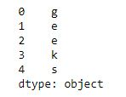

By default, the index of the series starts from 0 till the length of series -1.

**Creating a series from array with an index:** In order to create a series by explicitly proving index instead of the default, we have to provide a list of elements to the index parameter with the same number of elements as it is an array.

# import pandas as pd

import pandas as pd

# import numpy as np

import numpy as np

# simple array

data = np.array(['g', 'e', 'e', 'k', 's'])

# providing an index

ser = pd.Series(data, index=[10, 11, 12, 13, 14])

print(ser)

**Output:**

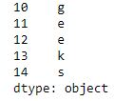

[**Creating a series from Lists**](https://www.geeksforgeeks.org/creating-a-pandas-series-from-lists/)**:** In order to create a series from list, we have to first create a list after that we can create a series from list.

import pandas as pd

# a simple list

list = ['g', 'e', 'e', 'k', 's']

# create series form a list

ser = pd.Series(list)

print(ser)

**Output :**



[**Creating a series from Dictionary**](https://www.geeksforgeeks.org/creating-a-pandas-series-from-dictionary/)**:** In order to create a series from the dictionary, we have to first create a dictionary after that we can make a series using dictionary. Dictionary keys are used to construct indexes of Series.

import pandas as pd

# a simple dictionary

dict = {'Geeks': 10,

        'for': 20,

        'geeks': 30}

# create series from dictionary

ser = pd.Series(dict)

print(ser)

**Output:**

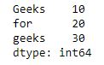

Pandas DataFrame

**Pandas DataFrame** is two-dimensional size-mutable, potentially heterogeneous tabular data structure with labeled axes (rows and columns). A Data frame is a two-dimensional data structure, i.e., data is aligned in a tabular fashion in rows and columns. Pandas DataFrame consists of three principal components, the **data**, **rows**, and **columns**.

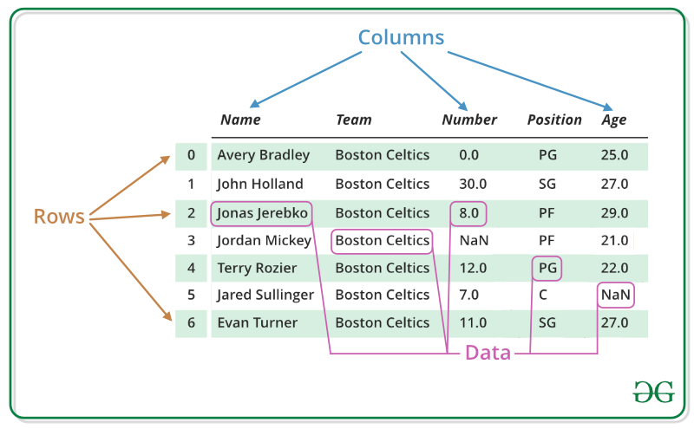

#### **Creating a Pandas DataFrame**

In the real world, a Pandas DataFrame will be created by loading the datasets from existing storage, storage can be SQL Database, CSV file, and Excel file. Pandas DataFrame can be created from the lists, dictionary, and from a list of dictionary etc. Dataframe can be created in different ways here are some ways by which we create a dataframe:

[**Creating a dataframe using List**](https://www.geeksforgeeks.org/create-a-pandas-dataframe-from-lists/)**:** DataFrame can be created using a single list or a list of lists.

|  |
| --- |
| # import pandas as pd  import pandas as pd    # list of strings  lst = ['Geeks', 'For', 'Geeks', 'is',              'portal', 'for', 'Geeks']    # Calling DataFrame constructor on list  df = pd.DataFrame(lst)  print(df) |
| **Output:**  https://media.geeksforgeeks.org/wp-content/uploads/df_from_list1.png |
|  |

[**Creating DataFrame from dict of ndarray/lists**](https://www.geeksforgeeks.org/python-create-a-pandas-dataframe-from-a-dict-of-equal-length-lists/)**:** To create DataFrame from dict of narray/list, all the narray must be of same length. If index is passed then the length index should be equal to the length of arrays. If no index is passed, then by default, index will be range(n) where n is the array length.

|  |
| --- |
| # Python code demonstrate creating  # DataFrame from dict narray / lists  # By default addresses.    import pandas as pd    # intialise data of lists.  data = {'Name':['Tom', 'nick', 'krish', 'jack'],          'Age':[20, 21, 19, 18]}    # Create DataFrame  df = pd.DataFrame(data)    # Print the output.  print(df) |
| **Output:** https://media.geeksforgeeks.org/wp-content/uploads/df2-1.png |

#### Dealing with Rows and Columns

A Data frame is a two-dimensional data structure, i.e., data is aligned in a tabular fashion in rows and columns. We can perform basic operations on rows/columns like selecting, deleting, adding, and renaming.

[**Column Selection**](https://www.geeksforgeeks.org/how-to-select-multiple-columns-in-a-pandas-dataframe/)**:** In Order to select a column in Pandas DataFrame, we can access the columns by calling them by their columns name.

|  |
| --- |
| # Import pandas package  import pandas as pd    # Define a dictionary containing employee data  data = {'Name':['Jai', 'Princi', 'Gaurav', 'Anuj'],          'Age':[27, 24, 22, 32],          'Address':['Delhi', 'Kanpur', 'Allahabad', 'Kannauj'],          'Qualification':['Msc', 'MA', 'MCA', 'Phd']}    # Convert the dictionary into DataFrame  df = pd.DataFrame(data)    # select two columns  print(df[['Name', 'Qualification']]) |
|  |

**Output:**  
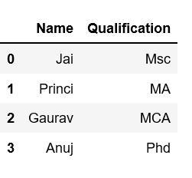

[Column Addition](https://www.geeksforgeeks.org/adding-new-column-to-existing-dataframe-in-pandas/)**:**  
In Order to add a column in Pandas DataFrame, we can declare a new list as a column and add to a existing Dataframe.

|  |
| --- |
| # Import pandas package  import pandas as pd    # Define a dictionary containing Students data  data = {'Name': ['Jai', 'Princi', 'Gaurav', 'Anuj'],          'Height': [5.1, 6.2, 5.1, 5.2],          'Qualification': ['Msc', 'MA', 'Msc', 'Msc']}    # Convert the dictionary into DataFrame  df = pd.DataFrame(data)    # Declare a list that is to be converted into a column  address = ['Delhi', 'Bangalore', 'Chennai', 'Patna']    # Using 'Address' as the column name  # and equating it to the list  df['Address'] = address    # Observe the result  print(df) |

**Output:**  
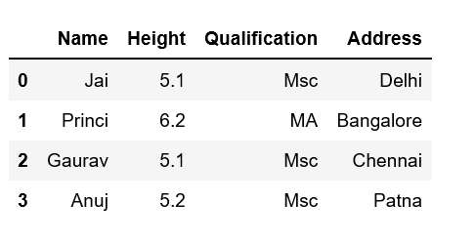

[Column Deletion](https://www.geeksforgeeks.org/python-delete-rows-columns-from-dataframe-using-pandas-drop/)**:**  
In Order to delete a column in Pandas DataFrame, we can use the drop() method. Columns is deleted by dropping columns with column names.

# importing pandas module

import pandas as pd

# making data frame from csv file

data = pd.read\_csv("nba.csv", index\_col ="Name" )

# dropping passed columns

data.drop(["Team", "Weight"], axis = 1, inplace = True)

# display

print(data)

**Output:**  
As shown in the output images, the new output doesn’t have the passed columns. Those values were dropped since axis was set equal to 1 and the changes were made in the original data frame since inplace was True.  
  
**Data Frame before Dropping Columns-**  
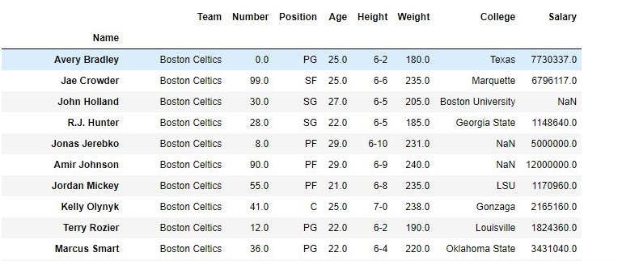  
  
**Data Frame after Dropping Columns-**  
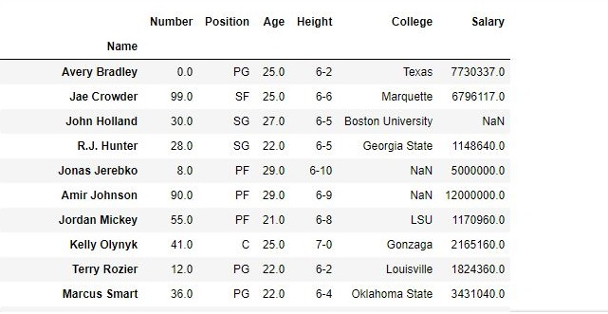

[**Row Selection**](https://www.geeksforgeeks.org/python-pandas-extracting-rows-using-loc/)**:** Pandas provide a unique method to retrieve rows from a Data frame. [DataFrame.loc[]](https://www.geeksforgeeks.org/python-pandas-extracting-rows-using-loc/" \t "_blank) method is used to retrieve rows from Pandas DataFrame. Rows can also be selected by passing integer location to an [iloc[]](https://www.geeksforgeeks.org/python-extracting-rows-using-pandas-iloc/" \t "_blank) function.  
  
**Note:** We’ll be using [nba.csv](https://media.geeksforgeeks.org/wp-content/uploads/nba.csv) file in below examples.

|  |
| --- |
| # importing pandas package  import pandas as pd    # making data frame from csv file  data = pd.read\_csv("nba.csv", index\_col ="Name")    # retrieving row by loc method  first = data.loc["Avery Bradley"]  second = data.loc["R.J. Hunter"]      print(first, "\n\n\n", second) |

**Output:**  
As shown in the output image, two series were returned since there was only one parameter both of the times.  
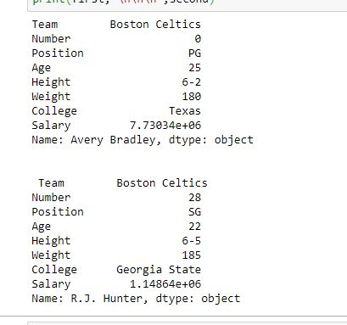

[Row Addition](https://www.geeksforgeeks.org/add-a-row-at-top-in-pandas-dataframe/)**:**  
In Order to add a Row in Pandas DataFrame, we can concat the old dataframe with new one.

|  |
| --- |
| # importing pandas module  import pandas as pd    # making data frame  df = pd.read\_csv("nba.csv", index\_col ="Name")    df.head(10)    new\_row = pd.DataFrame({'Name':'Geeks', 'Team':'Boston', 'Number':3,                          'Position':'PG', 'Age':33, 'Height':'6-2',                          'Weight':189, 'College':'MIT', 'Salary':99999},                                                              index =[0])  # simply concatenate both dataframes  df = pd.concat([new\_row, df]).reset\_index(drop = True)  df.head(5) |

**Output:**  
  
**Data Frame before Adding Row-**  
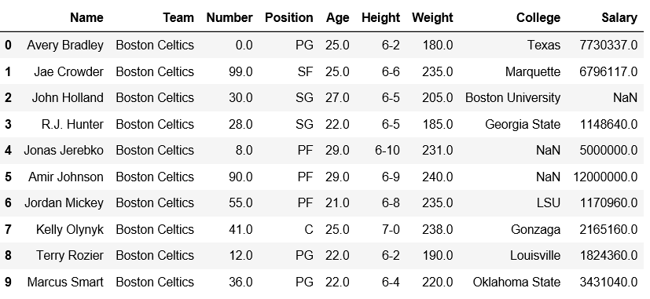  
  
**Data Frame after Adding Row-**  
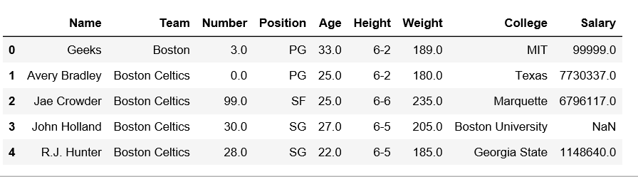

[Row Deletion](https://www.geeksforgeeks.org/python-delete-rows-columns-from-dataframe-using-pandas-drop/)**:**  
In Order to delete a row in Pandas DataFrame, we can use the drop() method. Rows is deleted by dropping Rows by index label.

|  |
| --- |
| # importing pandas module  import pandas as pd    # making data frame from csv file  data = pd.read\_csv("nba.csv", index\_col ="Name" )    # dropping passed values  data.drop(["Avery Bradley", "John Holland", "R.J. Hunter",                              "R.J. Hunter"], inplace = True)    # display  data |

**Output:**  
As shown in the output images, the new output doesn’t have the passed values. Those values were dropped and the changes were made in the original data frame since inplace was True.  
  
**Data Frame before Dropping values-**  
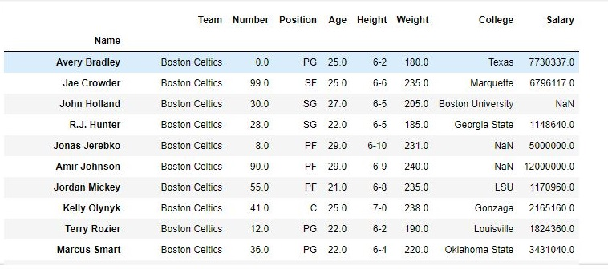  
  
**Data Frame after Dropping values-**  
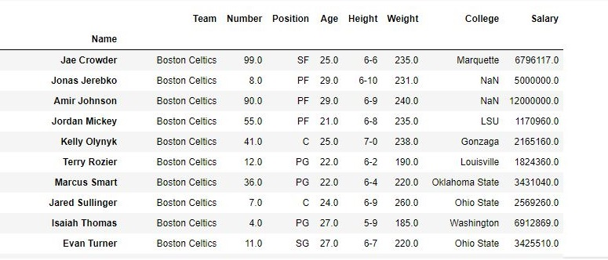

# Pandas.apply()

Pandas.apply allow the users to pass a function and apply it on every single value of the Pandas series. It comes as a huge improvement for the pandas library as this function helps to segregate data according to the conditions required due to which it is efficiently used in data science and machine learning.

To read the csv file and squeezing it into a pandas series following commands are used:

import pandas as pd

s = pd.read\_csv("stock.csv", squeeze=True)

**Syntax:**

s.apply(func, convert\_dtype=True, args=())

**Parameters:**

***func:****.apply takes a function and applies it to all values of pandas series.****convert\_dtype:****Convert dtype as per the function’s operation.****args=():****Additional arguments to pass to function instead of series.****Return Type:****Pandas Series after applied function/operation.*

The following example passes a function and checks the value of each element in series and returns low, normal or High accordingly.

|  |
| --- |
| import pandas as pd    # reading csv  s = pd.read\_csv("stock.csv", squeeze = True)    # defining function to check price  def fun(num):        if num<200:          return "Low"        elif num>= 200 and num<400:          return "Normal"        else:          return "High"    # passing function to apply and storing returned series in new  new = s.apply(fun)    # printing first 3 element  print(new.head(3))    # printing elements somewhere near the middle of series  print(new[1400], new[1500], new[1600])    # printing last 3 elements  print(new.tail(3)) |

**Output:**  
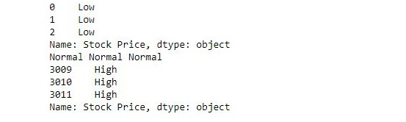

# Apply function to every row in a Pandas DataFrame

Python is a great language for performing data analysis tasks. It provides with a huge amount of Classes and function which help in analyzing and manipulating data in an easier way.   
One can use apply() function in order to apply function to every row in given dataframe.

**Example #1:**

# Import pandas package

import pandas as pd

# Function to add

def add(a, b, c):

    return a + b + c

def main():

    # create a dictionary with

    # three fields each

    data = {

            'A':[1, 2, 3],

            'B':[4, 5, 6],

            'C':[7, 8, 9] }

    # Convert the dictionary into DataFrame

    df = pd.DataFrame(data)

    print("Original DataFrame:\n", df)

    df['add'] = df.apply(lambda row : add(row['A'],

                     row['B'], row['C']), axis = 1)

    print('\nAfter Applying Function: ')

    # printing the new dataframe

    print(df)

if \_\_name\_\_ == '\_\_main\_\_':

    main()

**Output:** 

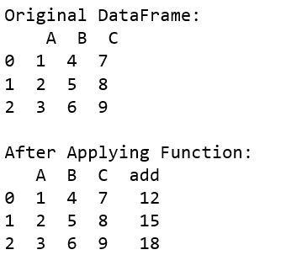

**Example #2:**  
You can use the numpy function as the parameters to the dataframe as well.

|  |
| --- |
| import pandas as pd  import numpy as np    def main():        # create a dictionary with      # five fields each      data = {              'A':[1, 2, 3],              'B':[4, 5, 6],              'C':[7, 8, 9] }        # Convert the dictionary into DataFrame      df = pd.DataFrame(data)      print("Original DataFrame:\n", df)        # applying function to each row in the dataframe      # and storing result in a new column      df['add'] = df.apply(np.sum, axis = 1)        print('\nAfter Applying Function: ')      # printing the new dataframe      print(df)    if \_\_name\_\_ == '\_\_main\_\_':      main() |

**Output:** 

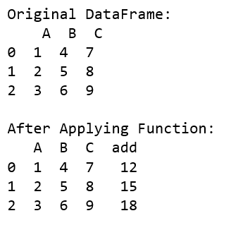

**Example #3:**Normalising Data

|  |
| --- |
| # Import pandas package  import pandas as pd    def normalize(x, y):      x\_new = ((x - np.mean([x, y])) /               (max(x, y) - min(x, y)))        # print(x\_new)      return x\_new    def main():        # create a dictionary with three fields each      data = {          'X':[1, 2, 3],          'Y':[45, 65, 89] }        # Convert the dictionary into DataFrame      df = pd.DataFrame(data)      print("Original DataFrame:\n", df)        df['X'] = df.apply(lambda row : normalize(row['X'],                                    row['Y']), axis = 1)        print('\nNormalized:')      print(df)    if \_\_name\_\_ == '\_\_main\_\_':      main() |

**Output:** 

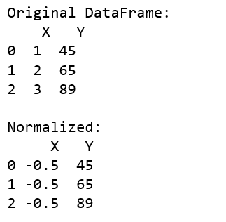

**Example #4:**Generate range

|  |
| --- |
| import pandas as pd  import numpy as np    pd.options.mode.chained\_assignment = None    # Function to generate range  def generate\_range(n):        # printing the range for eg:      # input is 67 output is 60-70      n = int(n)        lower\_limit = n//10 \* 10      upper\_limit = lower\_limit + 10        return str(str(lower\_limit) + '-' + str(upper\_limit))    def replace(row):      for i, item in enumerate(row):            # updating the value of the row          row[i] = generate\_range(item)      return row      def main():      # create a dictionary with      # three fields each      data = {              'A':[0, 2, 3],              'B':[4, 15, 6],              'C':[47, 8, 19] }        # Convert the dictionary into DataFrame      df = pd.DataFrame(data)        print('Before applying function: ')      print(df)        # applying function to each row in      # dataframe and storing result in a new column      df = df.apply(lambda row : replace(row))          print('After Applying Function: ')      # printing the new dataframe      print(df)    if \_\_name\_\_ == '\_\_main\_\_':      main() |

**Output:** 

